Predicting Stapled Peptide Permeability.
Source : Towards Understanding Cell Penetration by Stapled Peptides by Virdine, with the data found in the supplement material.

Aims of Project : Find features that are statistically significant to permeability.

Flow :
1. Preprocessing of data,
2. Analysis

1. Preprocessing of data
a). Converting data from sequence to smiles for RDKIT data mining
Sequence data was converted to smiles from with data/1_get_smiles.py and saved into ./interim/stapled_200.csv. Smiles format was used since RDKIT (a data mining tool) needs smiles format to calculate certain physical properties of the molecule.

b). Getting physical properties from RDKIT
data/2_get_RdkitFeatures.py does features engineering on the smiles molecules. It first converts the smile into a mol object within python and this is done with my make_info function. Numerous features from RDKIT were calculated (check rdkit documentation/tutorial page for more info), and saved in ./processed/stapled_peptide_permability_features.csv.

2. Analysis of important features
Since the dataset is extremely small, traditional statistical methods are used instead of empircal machine learning models. However , the data is believed to be sampled with bias. This makes generalizable to the entire population of peptides. The picture below illustrates biased sampling, where peptides with the highest permeability are from certain classes of peptides. Generally the biased comes from certain more 'popular' peptide classes, and their amino acids scans to possibly find critical residues affecting permeability. This biased sample will skew the results towards these peptides, and make it not generalizable across the entire population.

Peptides with highest florescence > 2000 are
quite identical
A way to overcome these not biased sampling is through reweighting of samples, where samples with a small probability of being chosen are given large weights and those samples which have a higher probability of being chosen given small weights. This correcting factor is well known in survey sampling (lohr 2010 chapter 6). I approximated the probability of being chosen as proportional number of peptides within each 'class of peptide'. Thus each 'class of peptide' has a sample weight of 1, and 'class of peptide' will be defined in the next paragraph.

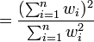
I have yet to define 'class of peptide', which I defined as similar peptides clustered within a certain sequence identity threshold. I used 99%, 90%, 85%, 80%, 70% sequence identity as a threshold. The total number of samples will be calculated with the kish effective sample size with sampling weights. Effective size

Analysis with sample weights (85% identity, corresponding to 1-2 amino acid differences)
The results are largely similar to that of 99% identity, though generally the amino acids with large error bars generally disappeared, but the aromatic amino acids and (D,E,Q,N) amino acids are positively and negatively correlated with permeability respectively. H and aromatic heterocycles (H and W) are also noted to be negatively correlated with permeability. The point in green is number of residues, and it is noted that larger peptides have poorer permeability, noted by the negative coefficient of 'number of residues'.
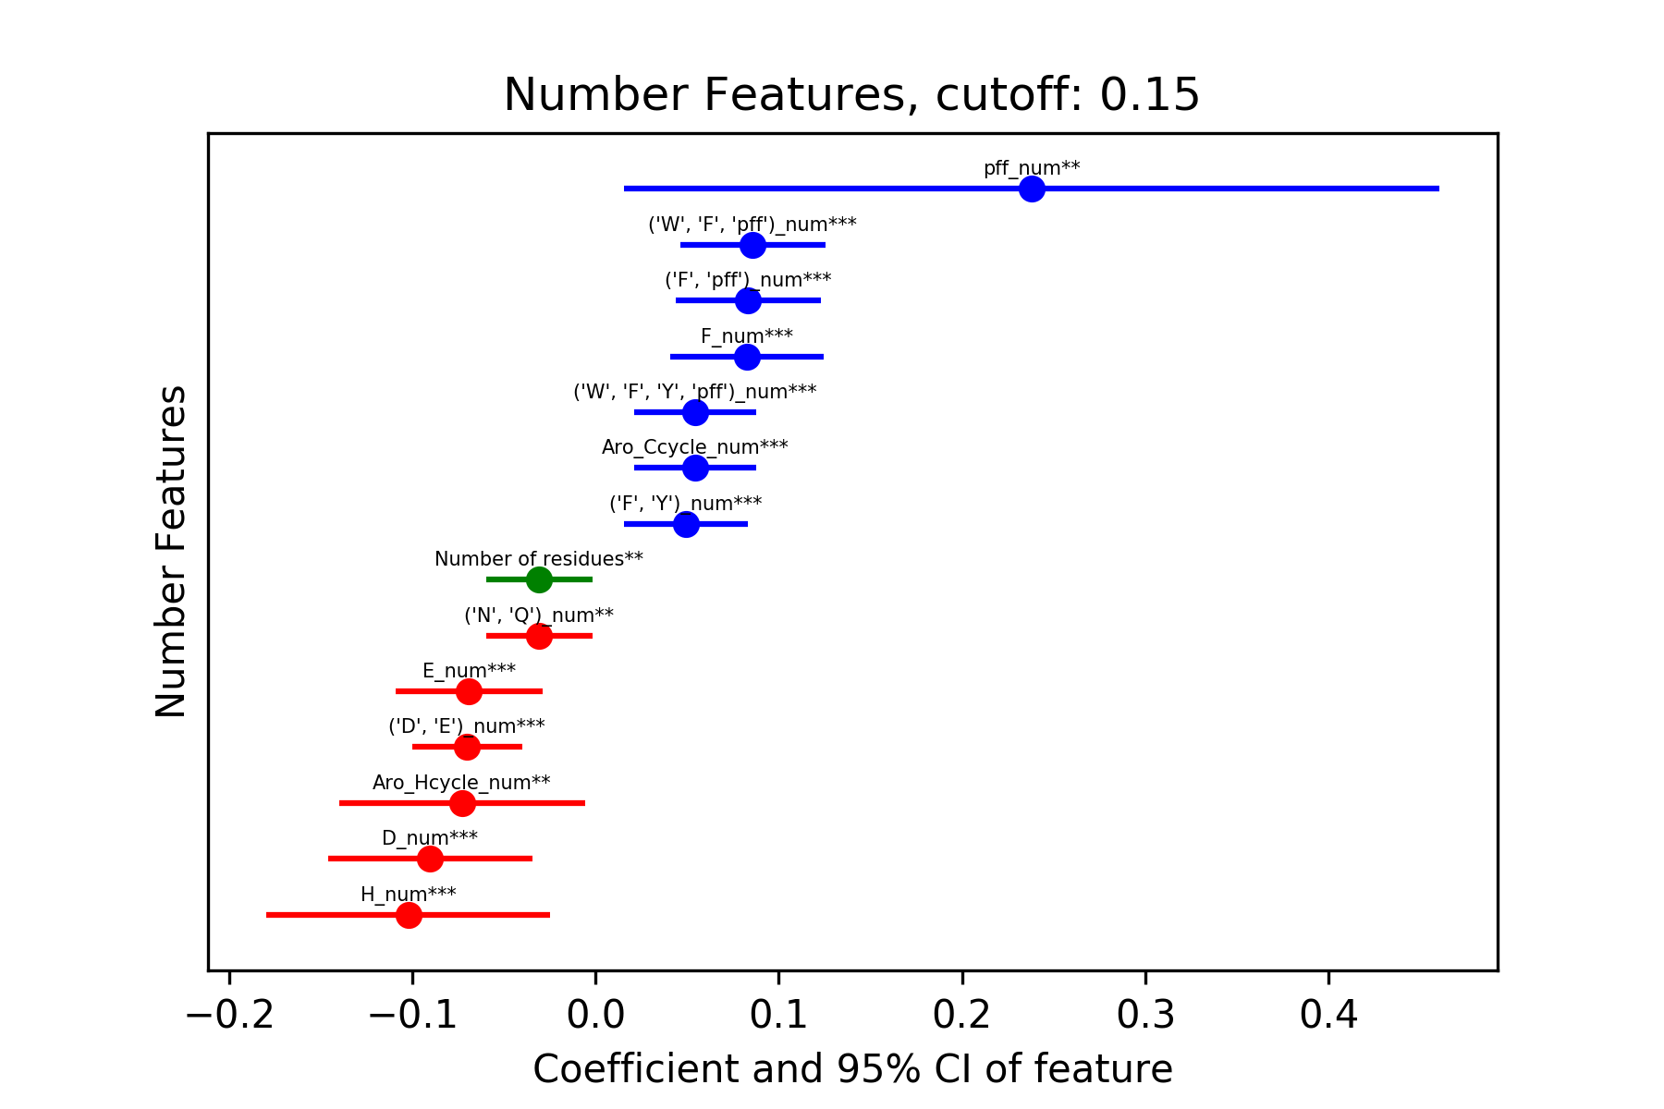

Results with other sample weights and normalized (by sequence length) features can be found in the reports/figures folder.

Analysis without sample weights (99% identity)
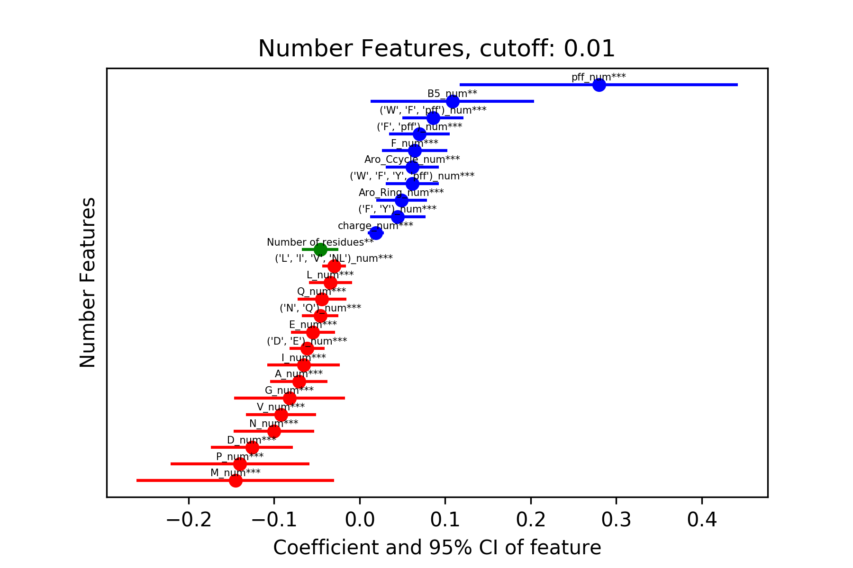
There are large similarities with that of 85% identity.
Figure : Number of residues and the coefficient and bootstraps confidence intervals.

R uncorrelated with peptides of higher permaebility
It is noted that R is not correlated with a higher permeability, contrary to literature reports. Below are the plots of R_num vs permeability. Without accounting for the biased sampling, R is positively correlated with permeability, with regression coefficient 0.011, which means a 2% increase in permaebility per additional R. However, this correlation disappears upon factoring in the bias, and the correlation drops to 0.This means that the majority of highly permeable R rich peptides are centered around a few peptides classes.
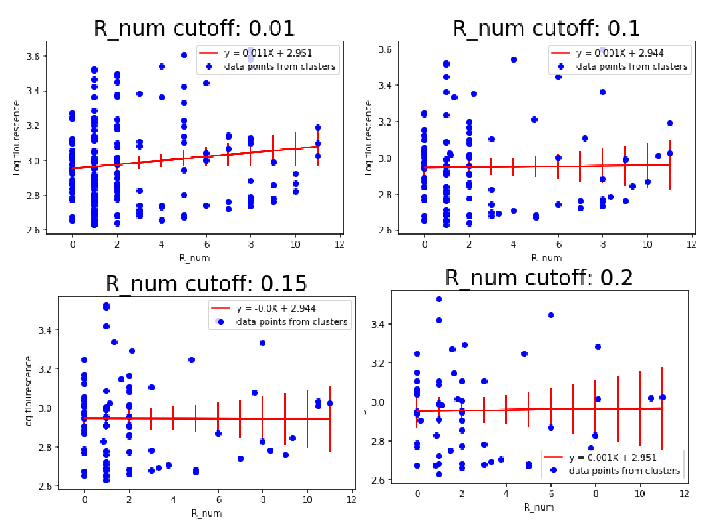
Permeability vs number of R amino acids. Each blue dot represents a peptide cluster with cut off 0.01, 0.1, 0.15, 0.2 representing 99, 90, 85, 80% sequence identity. Red line is the regression line with error bars of the regression line depicted.

Hydrophobic residues W, F and pff are positively correlated with permeability
As seen in the next figure, W,F and pff are positively correlated with peptide permaebility across various sequence identity cutoffs.
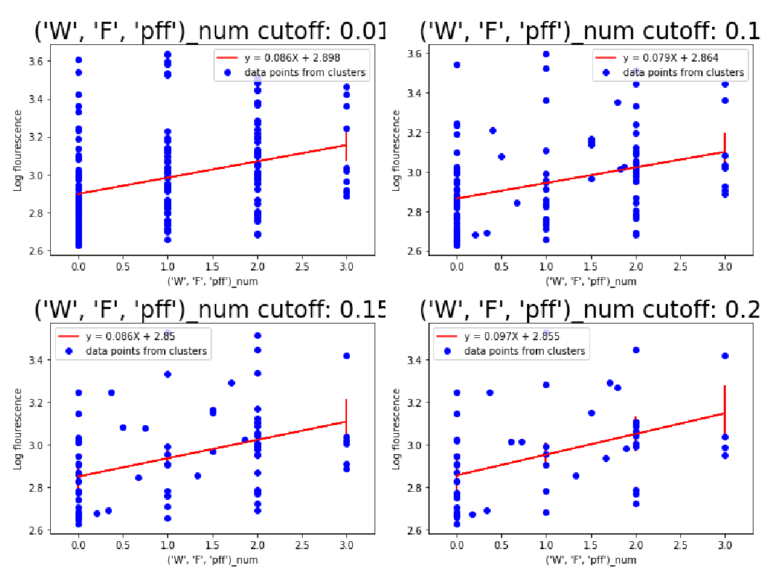

Making a full model with all statisitcally significant features
I made a model with all the statistically significant features, and the corr coef was found to be ~0.6,
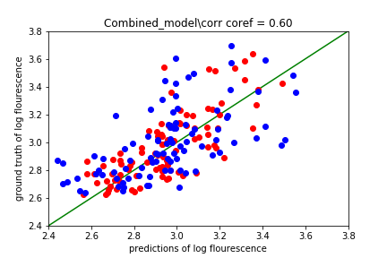

Take aways:
Pff is worth looking to
F,W, pff are positively correlated with permeability
D,E,Q,N are negatively correlated with permeability
R is possibly correlated with permeability, with a borderline statistical significance.

